Assignment Tutorial & Report

For Atmel Corp

Anantharaman R
04 Dec 2016

1) Introduction: 3
2) Tools Used: 3
3) Implementation: 3
Steps to follow for building the work environment: 3
UART Connection Establishment to Terminal: 3
Atmel Studio and ASF update: 3
4) Execution of the Functionalities: 4
➢ Displaying name and Company in OLED display as home screen: 4
➢ Displaying name in Teraterm Terminal Window: 4
➢ Swapping two variables without using a temporary variable: 4
➢ Counting number of set bits in the passed variable: 4
➢ Checking the bit position passed in the variable: 5
➢ Implementing basic CRC driver module: 5
5) Results: 6
6) Package Info: 8

Introduction:

The board used for the assignment is SAM4S Xplained Pro Starter Kit with SAM4SD32 Microcontroller

This tutorial will discuss about the features/ functioanality implemented in the assignment given as specified below

  - Displaying name and Company in OLED display as home screen
  - Displaying name in Teraterm Terminal Window
  - Swapping two variables without using a temporary variable
  - Counting number of set bits in the passed variable
  - Checking the bit position passed in the variable
  - Implementing basic CRC driver module

Tools Used:

  - SAM4S Xplained pro evaluation board
  - 3 Extention headers – OLED, IO and PROTO
  - Atmel Studio 7
  - Latest Atmel Software Framework(ASF 3.3.0)
  - Teraterm as UART Terminal

Implementation:

Steps to follow for building the work environment:

UART Connection Establishment to Terminal:
Connect the Teraterm application to COM3 Serial communication which is used by SAM4S Xplained
Pro for debug (EDBG).

Atmel Studio and ASF update:
  - Install Atmel Studio 7.0
  - Update ASF to the latest version
  - Create an empty ASF project for Starter kit SAM4S Xplained Pro board
  - Build the solution
  - Program the binary using EDBG tool configured in the project configuration
  - Run Atmel Studio to debug
  - Connect OLED Extension to EXT3 header

Execution of the Functionalities:

Displaying name and Company in OLED display as home screen:

Anantharaman Ramachandran
Atmel Corp

The above will be displayed in OLED

Displaying name in Teraterm Terminal Window:

While the above mentioned text is displayed in OLED

Name alone will be displayed in Teraterm window

Swapping two variables without using a temporary variable:

Then Press Button 1 to display Swap Variable screen in OLED

While in Teraterm window, A text related to the operation for the inputs will be displayed

Enter the respective values for the 2 variables to be swapped and press ENTER

Now, You will see the result in the Teraterm window

Counting number of set bits in the passed variable:

Then Press Button 1 to display Count bits screen in OLED

While in Teraterm window, A text related to the operation for the inputs will be displayed

Enter the respective values for the variable for which the set bits to be counted and press ENTER

Now, You will see the result in the Teraterm window

Checking the bit position passed in the variable:

Then Press Button 1 to display Swap Variable screen in OLED

While in Teraterm window, A text related to the operation for the inputs will be displayed

Enter the respective values for the variable and the bit position for which the corresponding value
from the variable is to be returned and press ENTER

Now, You will see the result in the Teraterm window

Implementing basic CRC driver module:

Then Press Button 1 to display CRC screen in OLED

While in Teraterm window, A text related to the operation for the inputs will be displayed

Enter the respective valid values for the Start Address, Length and CRC Mode for CRC Calculation and
press ENTER

Now, You will see the result in the Teraterm window

For all the above operations, any invalid entry will be notified in the Teraterm window or ignored.

Results:

Name Display in OLED as Home Screen after PowerOn:
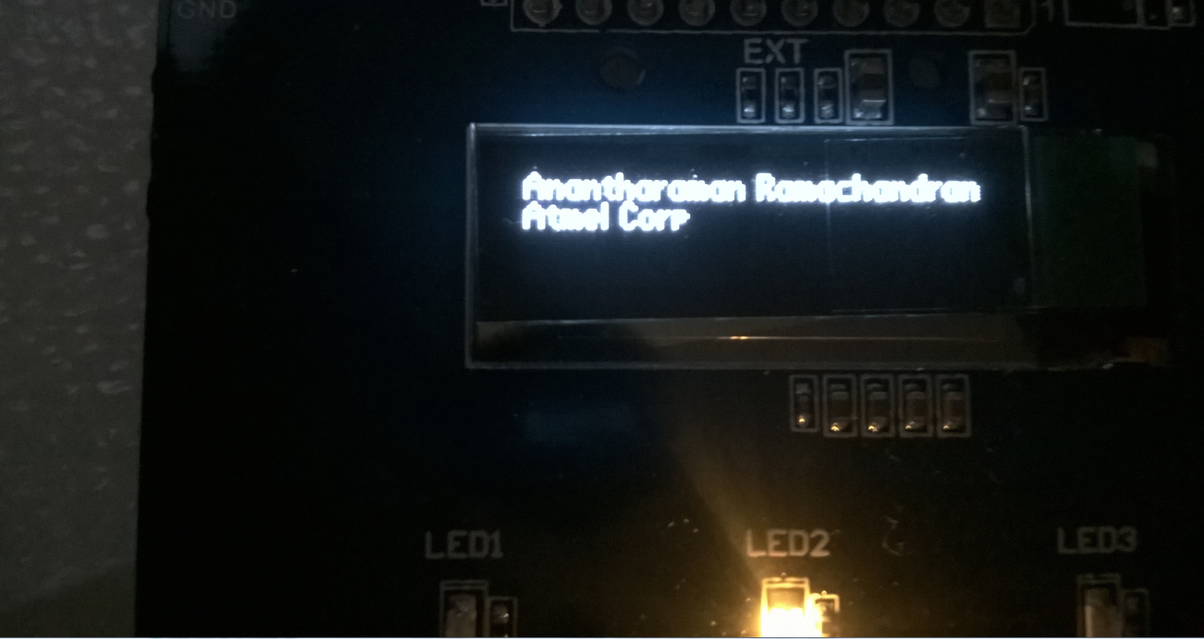

Debug Window Screenshot for Name Display:
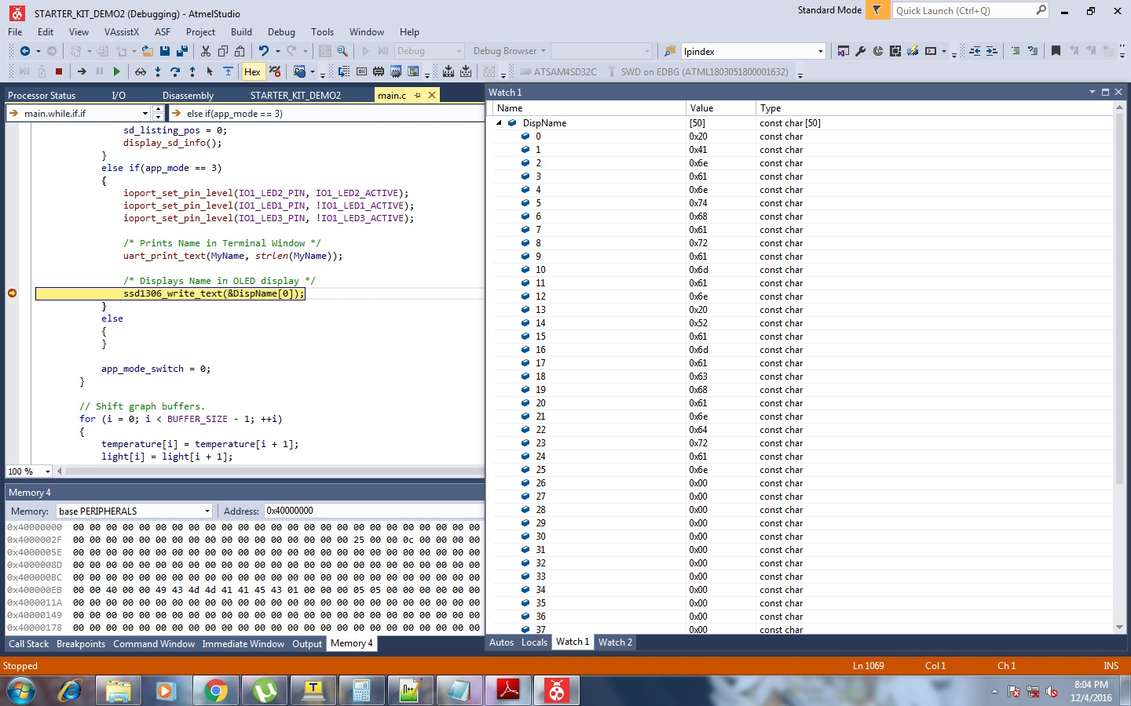

Teraterm Terminal Screenshot for Code Assignment:
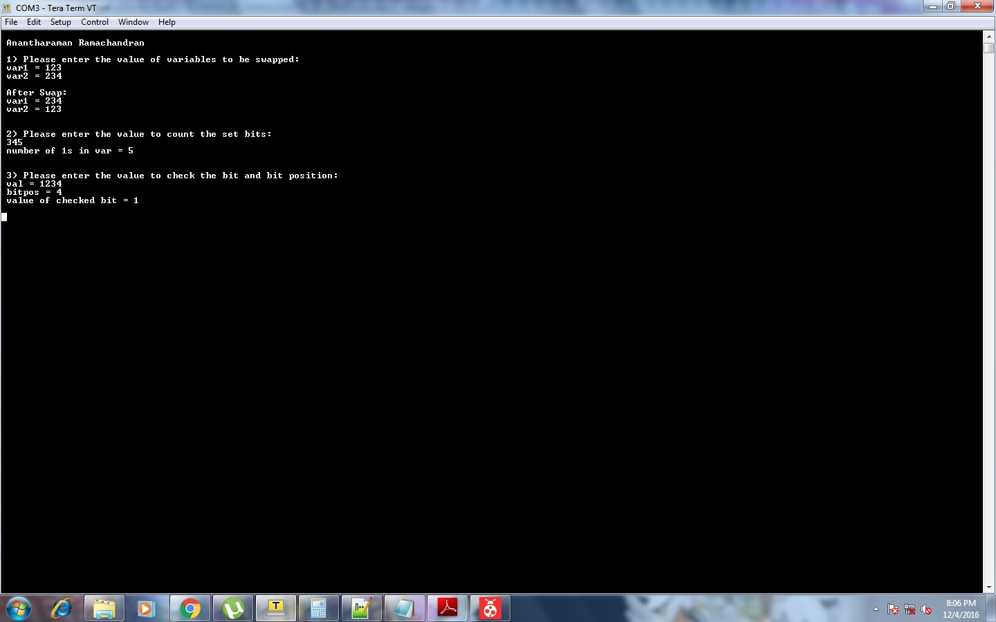

Package Info:

This Assignment is placed in GitHub for reference

